Telco Customer Churn Prediction using Decision Tree and Random Forest

Problem Statement:
The Telco Customer Churn dataset contains information about customers of a fictional telecom company. The objective is to predict whether a customer will churn (leave the service) based on their demographic, service usage, and account details.

The dataset includes features based on:
- Demographics: gender, SeniorCitizen, Partner, Dependents
- Services: InternetService, TechSupport, StreamingTV, etc.
- Account Info: Contract, PaymentMethod, MonthlyCharges, TotalCharges
- Target Variable: Churn (Yes → 1, No → 0)

The detailed list for all 21 features is shown in the image:
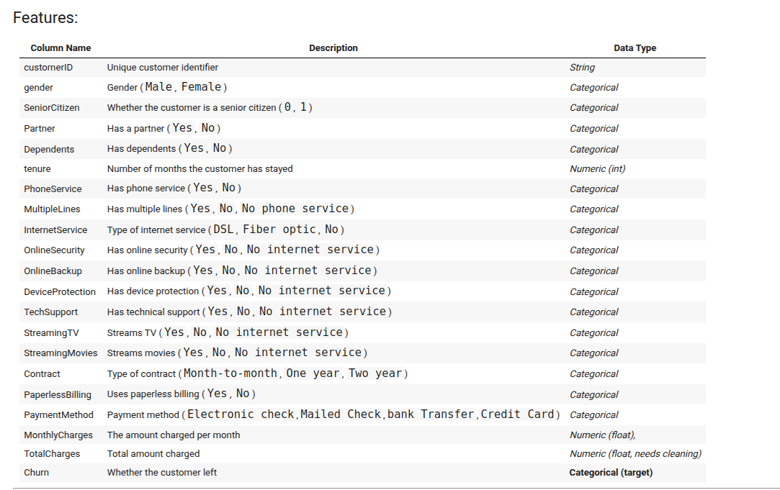

The workflow consists of two main parts:
Part A. Decision Tree Analysis
Part B. Random Forest Analysis

The following steps were performed in the Data Preparation/Preprocessing stage:

- Cleaned the TotalCharges column and handled missing values.
- Merged "No internet service" and "No phone service" into "No" to reduce category noise.
- Discretized tenure, MonthlyCharges, and TotalCharges into 4 quantile-based bins.
- Applied one-hot encoding to all categorical variables.
- Converted the Churn column to a binary label (Yes → 1, No → 0).

Part A. Decision Tree Analysis
Tree Depth Tuning:
- Decision trees were trained with max_depth values ranging from 1 to 29.
- Depth 6 was identified as optimal, providing the highest test accuracy before signs of overfitting appeared.
Train-Test Split Ratio Analysis:
- Different train-test splits were evaluated, including 60/40, 70/30, 80/20, and 90/10.
- The 80/20 split was found to offer the best balance across key metrics such as accuracy, F1 score, and AUC.
Final Decision Tree Evaluation:
- Final models were trained using both the "entropy" and "gini" criteria.
- Evaluation included metrics like accuracy, precision, recall, F1 score, and AUC.
- The trained decision tree was also visualized for interpretability using a tree plotting function

Part B. Random Forest Analysis
Tuning n_estimators:
- Random Forest models were trained with 50, 75, 100, and 150 trees.
- The best performance was observed with 150 trees.
Tuning max_features:
- Feature subsets ranging from 5 to 29 were tested at each split.
- The best results were achieved when using 15 features, providing the highest F1 score and a strong balance between precision and recall.
Final Random Forest Evaluation:
- Models were trained using both the "entropy" and "gini" criteria.
- Comprehensive evaluation was performed on the test set using accuracy, precision, recall, F1 score, and AUC.
- The highest test accuracy of 80.1% was achieved using the Gini criterion.

